Lab 3 – Utilizing Standard RGB Imagers for Scientific Purposes

Yuval Levental, Group 4RIT Center for Imaging Science, 54 Lomb Memorial Drive Rochester, NY 14623

**ABSTRACT**

In this laboratory, a typical RGB imager camera, the Nikon D50, is used to estimate the temperature of a blackbody tungsten halogen bulb. To perform this task, calibration curves are derived from data collected from an integrated sphere through a calibrated spectrometer.1

**Keywords:** Calibration, RGB Imager, blackbody, calibration sphere, radiance

1. **INTRODUCTION**

Several images are acquired at various illumination conditions. Those images consist of the integrating sphere and of the tungsten bulb. Additionally, the TA will use the calibrated spectrometer to acquire radiance measurements of the sphere.

The images and spectra will be used to perform a multi-point RGB-channel camera calibration to convert raw digital count values to radiance values. After this is done, the spectral range is integrated over to obtain a single radiance value for each channel. The best matched calibrated radiance value is related to the initial input temperature. Using a ROI at the center of the source, the average estimate of the temperature is calculated. Eventually, the radiance values of the Tungsten bulb are each divided by the maximum RGB value to normalize the values. This is because the absolute radiance of the Planck equation is not the same as the absolute radiance of the Tungsten bulb, but the wavelength distribution is the same.

Both the camera calibration and black body temperature routines are programmed in MATLAB, with code outlines provided for convenience.

1. **PROCEDURES**

The sphere and associated spectrometer are warmed up for 45 minutes. The Nikon D50 camera is placed in front of the sphere in such a way that the optical axis is directly in line with the center of the sphere’s exit aperture. The optical rail and lens are properly adjusted. The tungsten bulb is set at an ideal brightness, where the shutter speed of 1/640, ISO (sensitivity) of 200, and F/number (Aperture) of 13 were selected and recorded.

Nine illumination settings based on percent aperture closed were selected, which were in the range of the tungsten bulb. The percents closed are 46%, 48%, 49%, 51%, 54%, 56%, 57%, 58%, and 60%. The illumination conditions are captured using the camera. Additionally, the TA uses the spectrometer to obtain the sphere’s radiance measurements. Following this, pictures of the tungsten bulb are captured at various camera settings, including one picture where paper is covering the bulb.

1. **ANALYSIS AND RESULTS**

In setting up the lab equipment, the integrating sphere needs to warm up because the sphere needs to be at a stable level of brightness. It needs enough constant electric power for this purpose. If the camera is too close to the sphere, the light will be too powerful for the camera sensors to accurately process. If the camera is too far by contrast, the sensors won’t be close enough to the brightness for proper readings.

The first step in analysis was to find the mean RGB DC Values of the LabSphere images for different aperture closed percentages. The images were imported and analyzed in MATLAB, and the results were entered into Table 2. Additionally, the spectral response curve was imported and interpolated for the RGB bands, so that each point from 400 to 700 nm was separated by 0.357, as it was determined that each spectrometer reading has approximately 840 values between those limits. The spectral radiance values from each spectrometer reading was multiplied by the spectral response curve for this range and by 0.357. The spectral response, plotted in Figure 1, gives an indication of what wavelength values are registered by the camera as RGB values. The results were summed together to obtain the radiance values, and those values were also entered into Table 2.

The derived regression equations using the matlab polyfit function were plotted in Figure 2.

Red: L = 0.0112*DC - 0.2645

Green: L = 0.0476*DC - 2.0542

Blue: L = 0.0185*DC – 0.6814

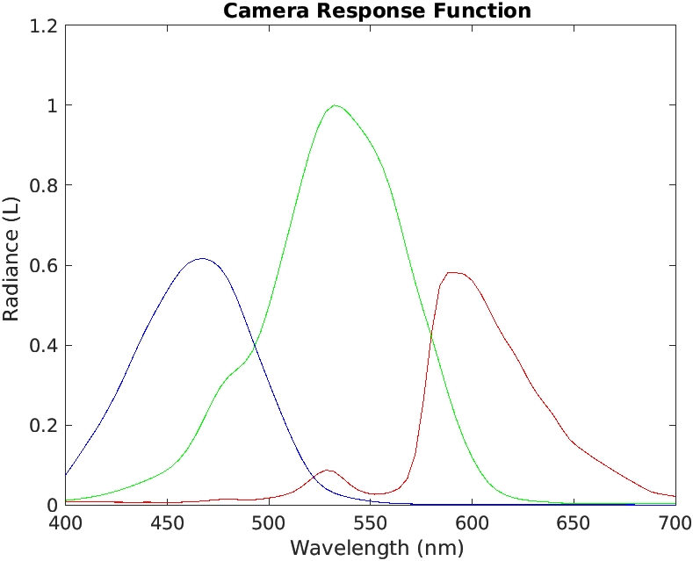 Figure 1. Camera Response Function

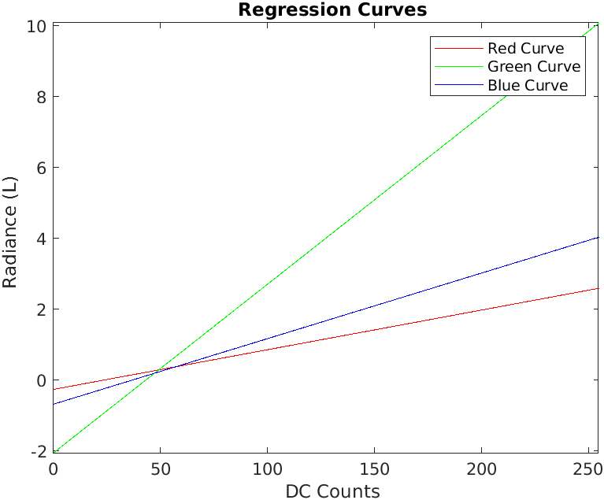 Figure 2. Plotted Regression Curves

The benefit of multiple point calibration is that the best fit for a line correlating the DC values with the radiances is much easier to find. Focusing on a single point would not be able to indicate the change of L with respect to DC.

The average RGB DC values for the lamp at the ideal camera settings recorded in the procedures section were determined in MATLAB to be (247.9816, 202.6223, 128.4978).

Red: L = 0.0112* 247.9816 – 0.2645 = 2.51289392

Green: L = 0.0476* 202.6223 – 2.0542 = 7.59062148

Blue: L = 0.0185*128.4978 – 0.6814 = 1.6958093

The next step was to integrate several Planck blackbody curves from 400 to 700 nm over various temperature ranges in Kelvins, plotted in Figure 3. The Planck blackbody curve is given in equation 1. I decided to use the standard first and second radiation constants.2 The temperature range I selected was from 2000-3000 K in increments of 50 K. The obtained blackbody radiance values were recorded in Table 3, and the relation was plotted in Figure 4.

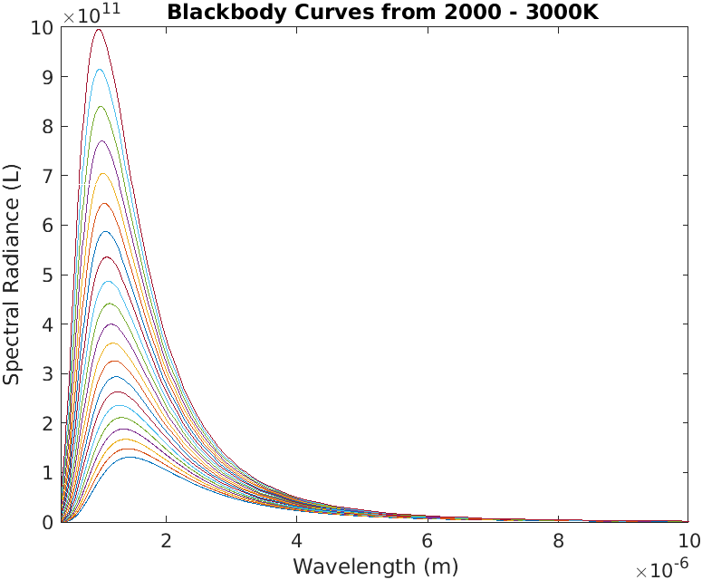 Figure 3. Plotted Blackbody curves.

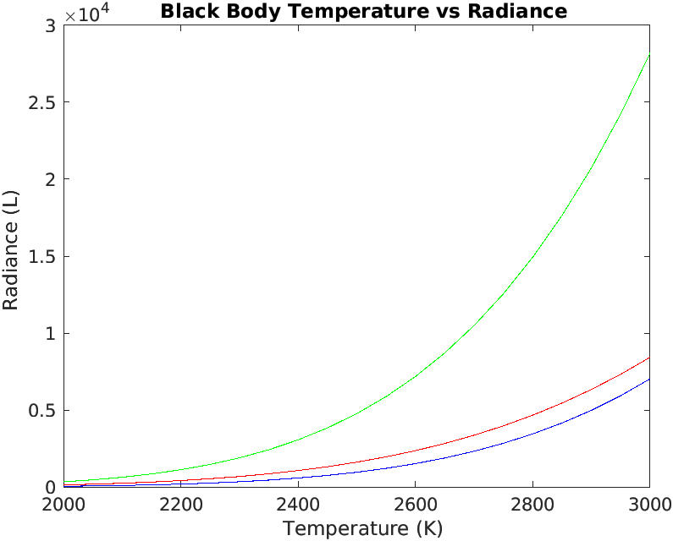 Figure 4. Blackbody temperature vs radiance

The absolute radiance of the Planck equation is not the same as the absolute radiance of the Tungsten bulb, but the wavelength distribution is the same. Therefore, the radiance values are normalized relative to the largest radiance value.

The normalized radiance values for the lamp are (0.3311, 1, 0.2234).

Additionally, the blackbody values in Table 3 were normalized in Excel relative to the largest value for each selected temperature. The absolute values of the differences between the RGB values of the lamp and black body were summed together, and it was discovered that the smallest residual difference was at 2700 K.

**The normalized radiance values for the blackbody curve at 2700K are (0.3206, 1, 0.2216). The minimum summed difference at this temperature is 0.0123.**

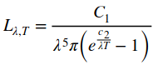

(1)

The estimate of temperature seems reasonable, as Tungsten lamps tend to become very bright. One possible improvement for this estimate is to obtain a spectral response curve with smaller interval spacing, as more accurate radiance values could be obtained for average RGB DC channel values.

1. **CONCLUSIONS**

In conclusion, the overall purpose of this lab was to learn how to estimate the temperature of a blackbody source using a digital camera. The purpose of an integrating sphere is to help determine the calibration function. In particular, the tungsten halogen bulb was used as the blackbody, and the digital camera was the Nikon D50. Compared to previous labs it was very challenging to set up the equipment, take the measurements, and find the estimated temperature. The linear regression equation is used to estimate the radiance from the obtained average RGB DC value. Interestingly enough, the data files were labeled in a way so that as the DC value increases, the spectrometer’s radiance decreases. My TA told me to plot the points in a way where the slope is positive. While the method to estimate temperature was reasonable, it would have been useful to have been given a preset range to derive the radiance curves.

**APPENDIX A. MATERIALS, RAW DATA, AND MATLAB CODE**

Table 1. Materials needed for the lab.

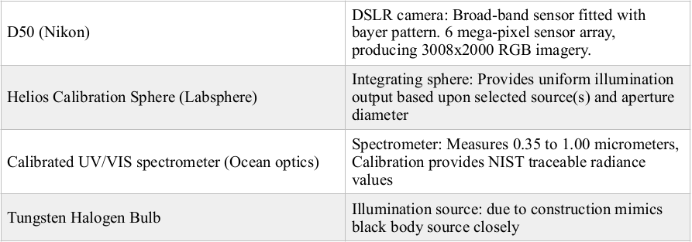 Table 2. DC Values vs Radiance

|  |  |  |  |  |  |  |
| --- | --- | --- | --- | --- | --- | --- |
| Percent Aperture Closed | DC Red Value | Red Radiance (L) | DC Green Value | Green Radiance (L) | DC Blue Value | Blue Radiance (L) |
| 46% | 158.7809 | 1.5733 | 178.2192 | 6.9366 | 175.1809 | 2.7300 |
| 48% | 147.7255 | 1.3995 | 170.6875 | 6.1661 | 166.6568 | 2.4205 |
| 49% | 142.3442 | 1.3111 | 167.4914 | 5.7751 | 162.8773 | 2.2652 |
| 51% | 130.4495 | 1.1453 | 156.6169 | 5.0404 | 150.3418 | 1.9724 |
| 54% | 109.019 | 0.9200 | 133.2538 | 4.0378 | 125.6085 | 1.5711 |
| 56% | 95.6830 | 0.7753 | 117.9825 | 3.4002 | 111.0052 | 1.3201 |
| 57% | 87.5391 | 0.7063 | 109.4818 | 3.0956 | 103.3265 | 1.2005 |
| 58% | 81.7319 | 0.6436 | 102.4305 | 2.8180 | 96.2710 | 1.0908 |
| 60% | 64.9301 | 0.5249 | 83.9794 | 2.2957 | 78.1041 | 0.8862 |

Table 3. Temperature vs Blackbody Planckian Radiance Values

|  |  |  |  |
| --- | --- | --- | --- |
| Temperature (K) | Red Radiance (L) | Green Radiance (L) | Blue Radiance (L) |
| 2000 | 136.5106 | 338.0816 | 49.3911 |
| 2050 | 184.4207 | 466.3444 | 70.8575 |
| 2100 | 245.6298 | 633.6719 | 99.9504 |
| 2150 | 322.8564 | 849.0692 | 138.7867 |
| 2200 | 419.1645 | 1.1229e+03 | 189.9035 |
| 2250 | 537.9745 | 1.4671e+03 | 256.3054 |
| 2300 | 683.0702 | 1.8950e+03 | 341.5107 |
| 2350 | 858.6033 | 2.4217e+03 | 449.5966 |
| 2400 | 1.0691e+03 | 3.0638e+03 | 585.2420 |
| 2450 | 1.3194e+03 | 3.8398e+03 | 753.7676 |
| 2500 | 1.6148e+03 | 4.7698e+03 | 961.1728 |
| 2550 | 1.9609e+03 | 5.8757e+03 | 1.2142e+03 |
| 2600 | 2.3636e+03 | 7.1812e+03 | 1.5202e+03 |
| 2650 | 2.8292e+03 | 8.7117e+03 | 1.8875e+03 |
| 2700 | 3.3642e+03 | 1.0494e+04 | 2.3251e+03 |
| 2750 | 3.9754e+03 | 1.2558e+04 | 2.8427e+03 |
| 2800 | 4.6701e+03 | 1.4932e+04 | 3.4509e+03 |
| 2850 | 5.4555e+03 | 1.7650e+04 | 4.1612e+03 |
| 2900 | 6.3392e+03 | 2.0744e+04 | 4.9858e+03 |
| 2950 | 7.3289e+03 | 2.4250e+04 | 5.9378e+03 |
| 3000 | 8.4328e+03 | 2.8203e+04 | 7.0308e+03 |

files = dir('*320f13iso200.JPG');

**for** i=1:length(files)

I = imread(files(i).name);

% Extract the red, green, and blue channels

redChannel = I(:,:,1);

greenChannel = I(:,:,2);

blueChannel = I(:,:,3);

% Get mean values

meanR = mean(redChannel(750:1250,1250:1750),'all') %rows, columns

meanG = mean(greenChannel(750:1250,1250:1750),'all') %rows, columns

meanB = mean(blueChannel(750:1250,1250:1750),'all') %rows, columns

**end**

I = imread('Light_exp1.640f13iso200.JPG');

% Extract the red, green, and blue channels

redChannel = I(:,:,1);

greenChannel = I(:,:,2);

blueChannel = I(:,:,3);

% Get mean values

meanR = mean(redChannel(500:1200,1380:2080),'all') %rows, columns

meanG = mean(greenChannel(500:1200,1380:2080),'all') %rows, columns

meanB = mean(blueChannel(500:1200,1380:2080),'all') %rows, columns

files = dir('*.csv');

A = readmatrix('D50_spectral_response.txt');

ri = interp1(A(:,1),A(:,2),linspace(400,700,840));

gi = interp1(A(:,1),A(:,3),linspace(400,700,840));

bi = interp1(A(:,1),A(:,4),linspace(400,700,840));

**for** i=1:length(files)

B = readmatrix(files(i).name);

Cr = ri(1,136:572).*transpose(B(268:704,2));

Cr = sum(Cr)*0.357

Cg = gi(1,136:572).*transpose(B(268:704,2));

Cg = sum(Cg)*0.357

Cb = bi(1,136:572).*transpose(B(268:704,2));

Cb = sum(Cb)*0.357

**end**

A = readmatrix('D50_spectral_response.txt');

T = 2000;

**for** T=2000:50:3000

f = @(x) (3.74151E-16)./((x.^5).*pi.*(exp((1.43879E-2)./(x.*T))-1));

Cr = A(13:51,2).*transpose(f(448*10.^-9:4*10.^-9:600*10.^-9));

Cr = sum(Cr)*4*10.^-9

Cg = A(13:51,3).*transpose(f(448*10.^-9:4*10.^-9:600*10.^-9));

Cg = sum(Cg)*4*10.^-9

Cb = A(13:51,4).*transpose(f(448*10.^-9:4*10.^-9:600*10.^-9));

Cb = sum(Cb)*4*10.^-9

**end**

**REFERENCES**

1. Bachmann, C. and Hughes, E., “Utilizing Standard RGB Imagers for Scientific Purposes”, Rochester Institute of Technology (2019).
2. IUPAC Compendium of Chemical Technology, (1997). Radiation Constants. Retrieved October 29, 2019 from https://www.micromeritics.com/Repository/Files/radiation_constants.pdf